**PROJECT TITLE :**

**To Supply Leftover Food to Poor**

**COLLEGE NAME : UNITED COLLAGE OF ARTS AND SCIENCE**

**COLLEGE CODE : brubl**

**TEAM ID : 27F024668CBF8178DA94B74E9F17958A**

**TEAM MEMBERS :**

**TEAM LEADER NAME : THARANI R**

**EMAIL :** [**tharaniravichandhran@Gmail.com**](mailto:tharaniravichandhran@Gmail.com)

**TEAM MEMBER 1 : SARAVANA S**

**EMAIL :**

[**Saravanansanjay115@Gmail.com**](mailto:Saravanansanjay115@Gmail.com)

**TEAM MEMBER 2 : SRI KAMALI K**

**EMAIL :**

[**Srikamali731@Gmail.com**](mailto:Srikamali731@Gmail.com)

**TEAM MEMBER 3 : SRIMATHI J**

**EMAIL :**

**Shrizshrimathi@Gmail.com**

**TEAM MEMBER 4 : THARANI S**

**EMAIL :**

**Nagamanisaravanan4@Gmail.com**

**To Supply Leftover Food to Poor**

Utilizing Salesforce, our project streamlines surplus food collection and distribution to the needy, ensuring efficiency and transparency.

**Salesforce developer account creation**

**Creating Developer Account**

Creating a developer org in salesforce.

1. Go to <https://developer.salesforce.com/signup>
2. On the sign up form, enter the following details
   1. First name & Last name
   2. Email
   3. Role : Developer
   4. Company : College or Company Name
   5. County : India
   6. Postal Code : pin code
   7. Username : should be a combination of your name and company

This need not be an actual email id, you can give anything in the format :

username@organization.com

Click on sign me up after filling these.

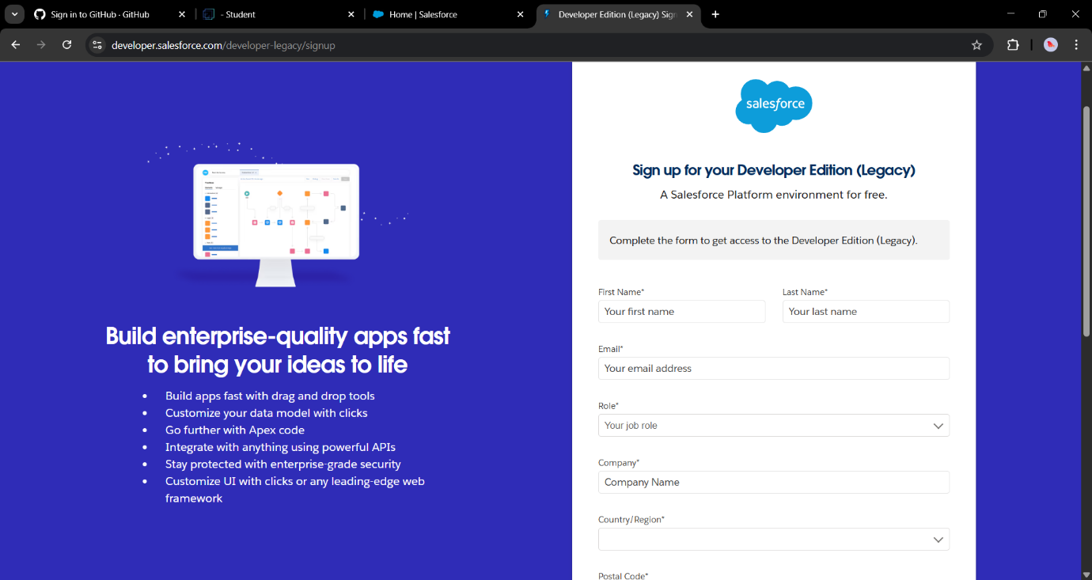

**Account Activation**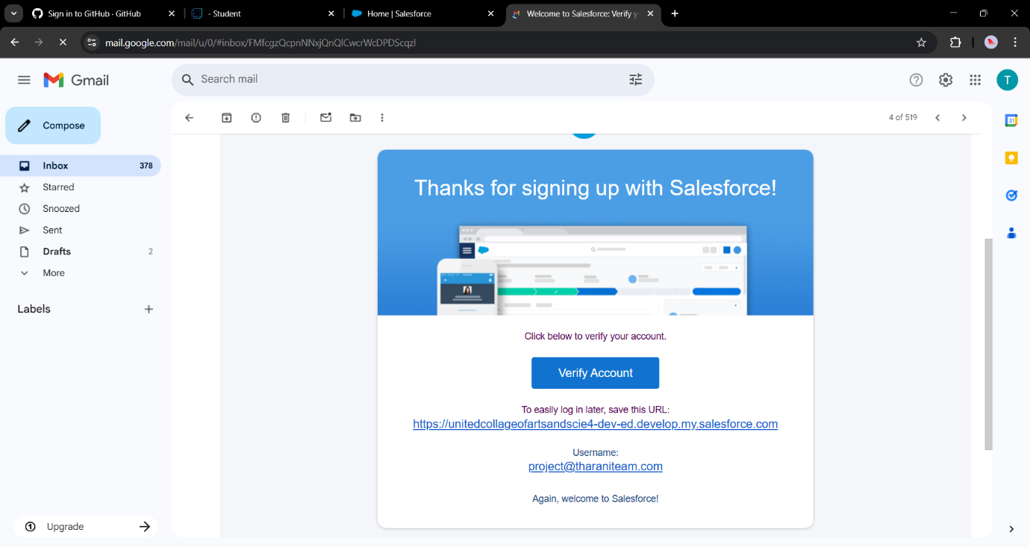

1. Go to the inbox of the email that you used while signing up. Click on the verify account to activate your account. The email may take 5-10mins.
2. Give a password and answer a security question and click on change password.
3. Give a password and answer a security question and click on change password.
4. Then you will redirect to your salesforce setup page.

**Object**

o Navigate to Setup page:

To create an object:

1. From the setup page > Click on Object Manager > Click on Create > Click on Custom Object.
2. On Custom object defining page:
3. Enter the label name, plural label name, click on Allow reports, Allow search.

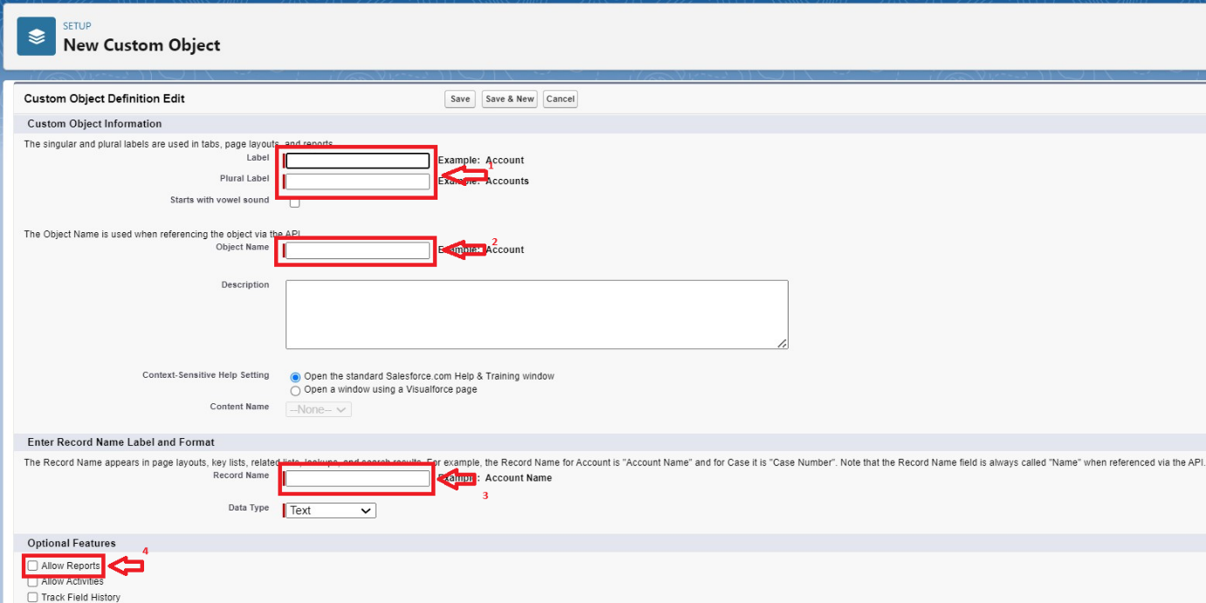

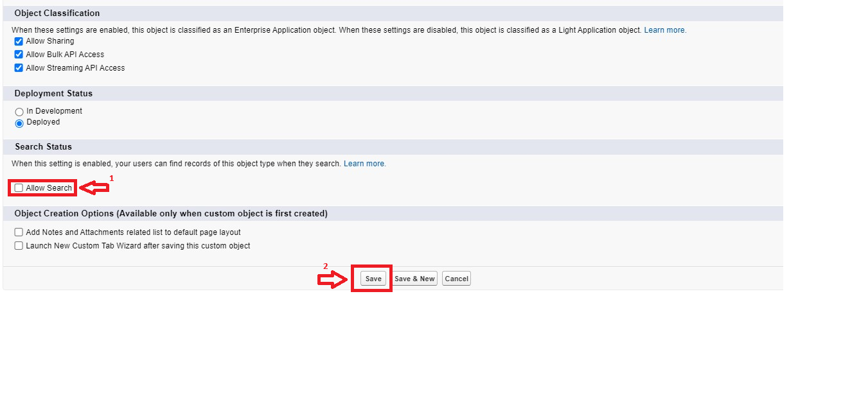

1. Click on Save.

**1.Create Venue Object**

**2.Create Drop-Off Point Object**

**3.Create Task Object**

**4.Create Volunteer Object**

**5.Create Execution Details Object**

**Tabs**

**A tab is like a user interface that is used to build records for objects and to view the records in the objects.**

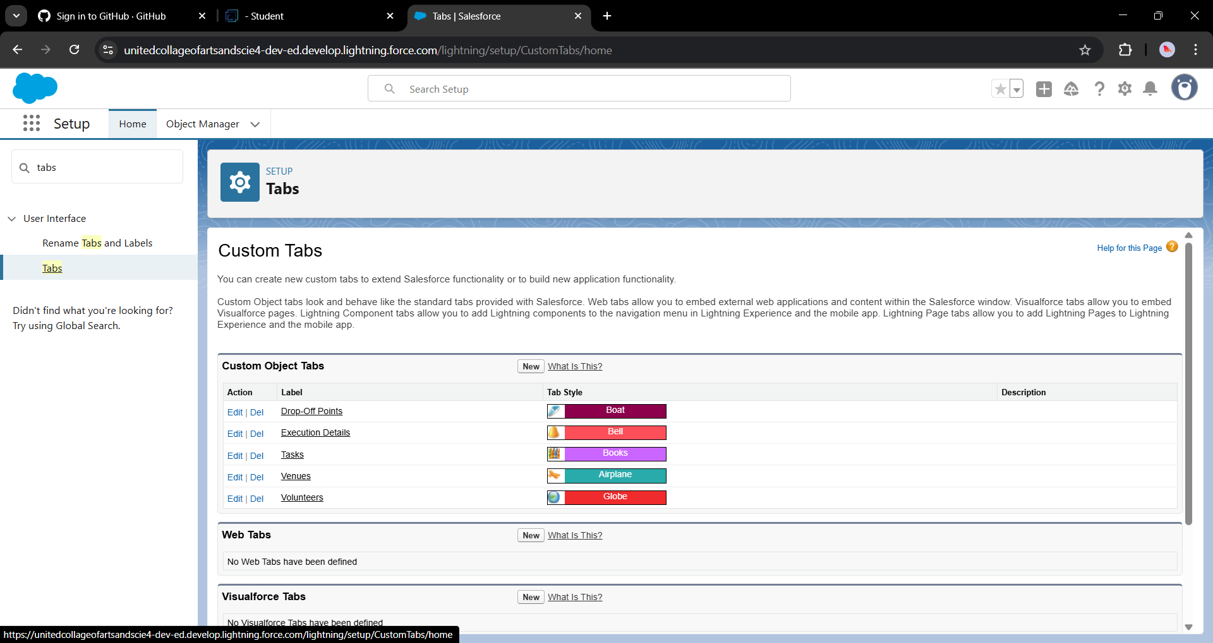

**Create a Lightning App**

**To create a lightning app page:**

1. Go to setup page >> search “app manager” in quick find >> select “app manager” >> click on New lightning App.

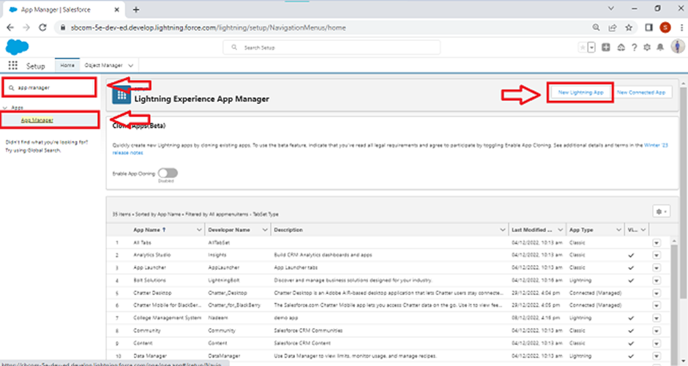

2. Fill the app name in app details and branding as follow  
App Name : FoodConnect  
Developer Name : This will auto populated  
Image : optional (if you want to give any image you can otherwise not mandatory) Primary color hex value : keep this default.

3.Then click Next  >> (App option page)Set Navigation Style as Standard Navigation >> Next.

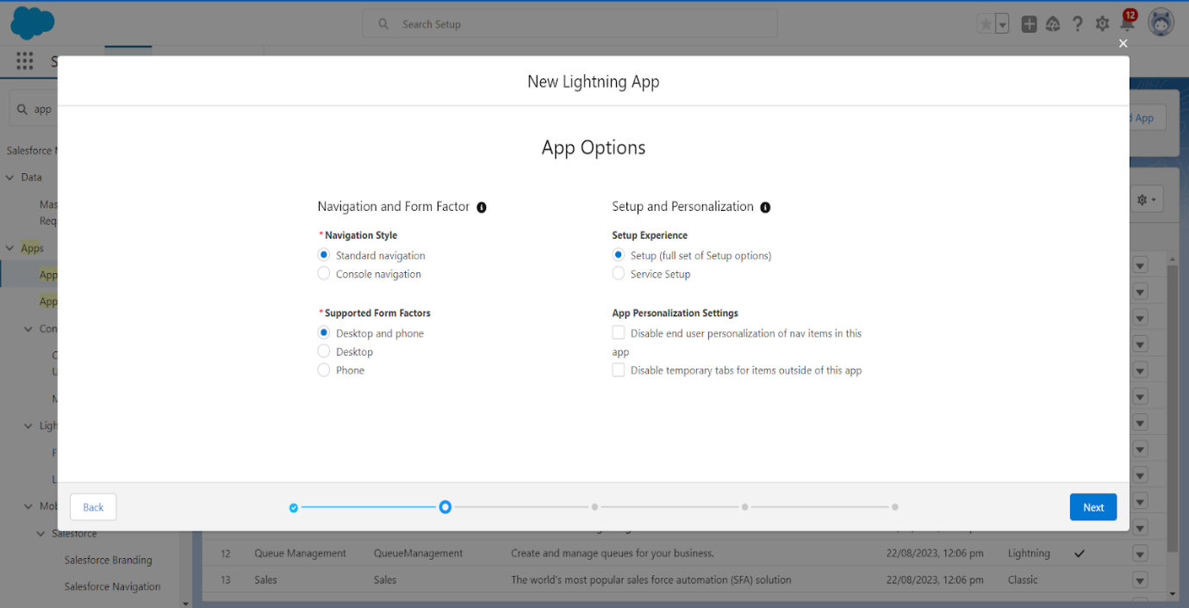

4. (Utility Items) keep it as default >> Next.  
5. To Add Navigation Items:

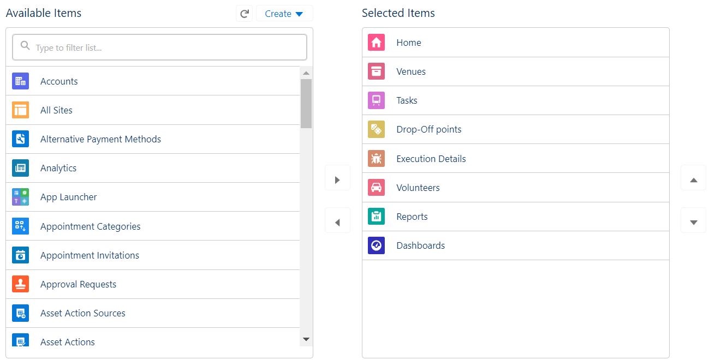

Search for the item in the (Home, Venue, Drop-Off Point, Task, Volunteer, Execution Details, Reports) from the search bar and move it using the arrow button >> Next >> Next.

6. To Add User Profiles:

**Fields**

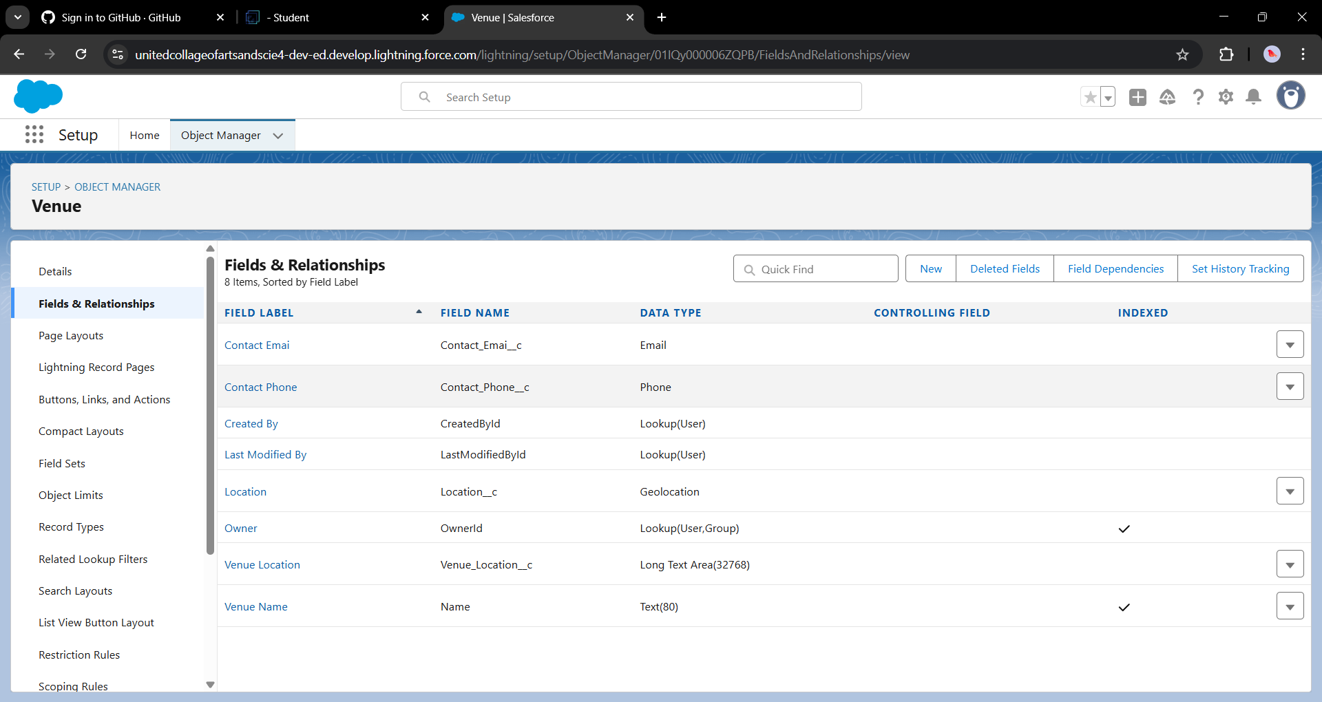

**Flows**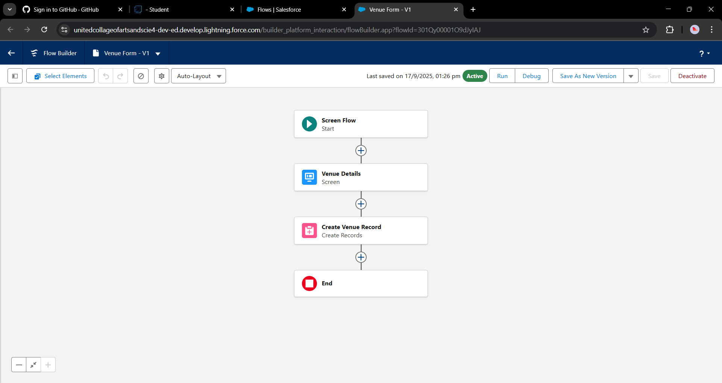

**Create Flow to create a record in Venue object**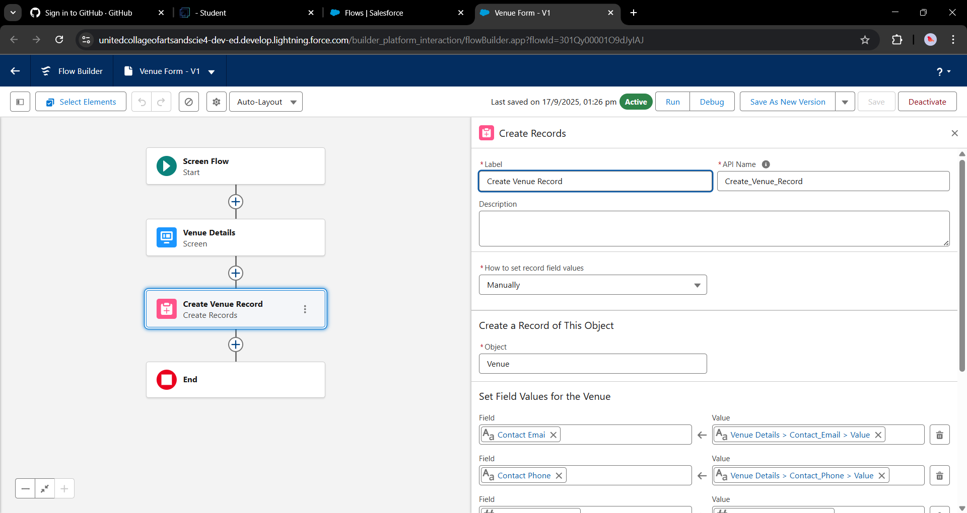

**Trigger**

**Create a Trigger** 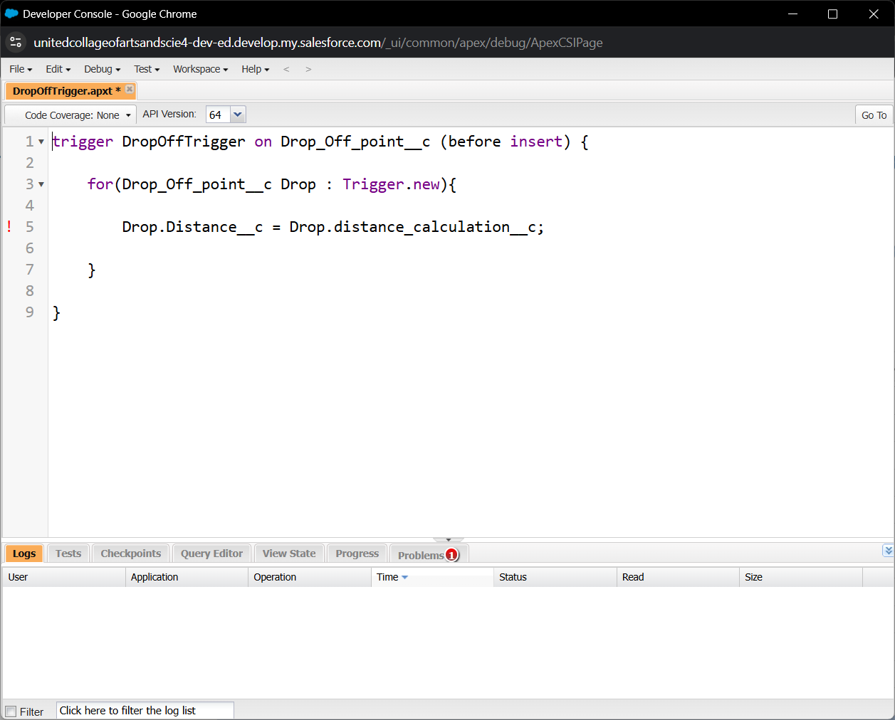

**Profiles**

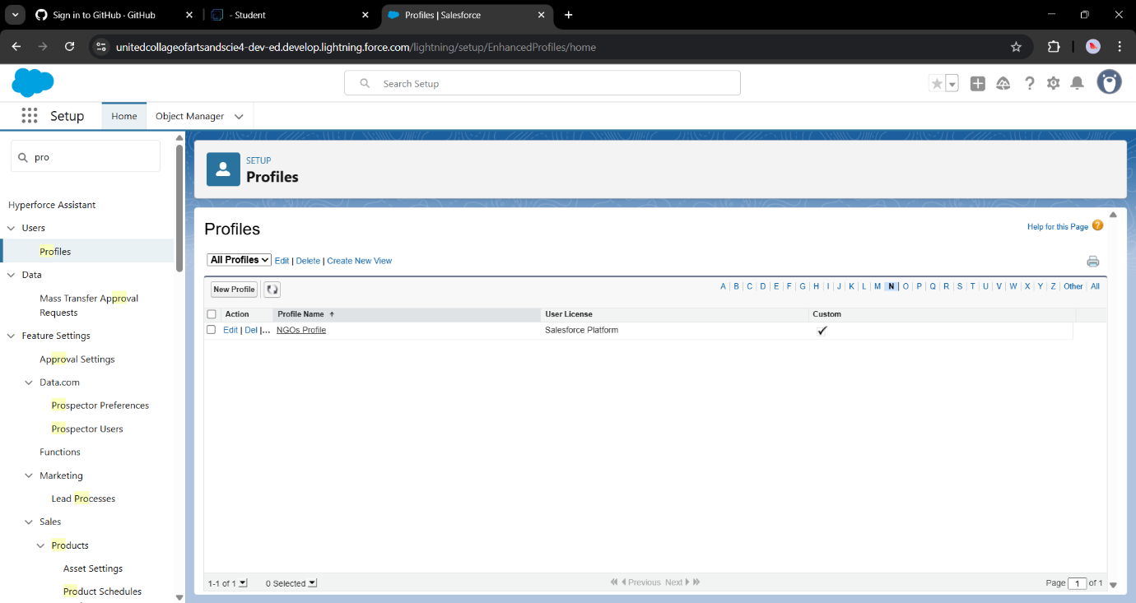

Users

In our project we consider them as NGO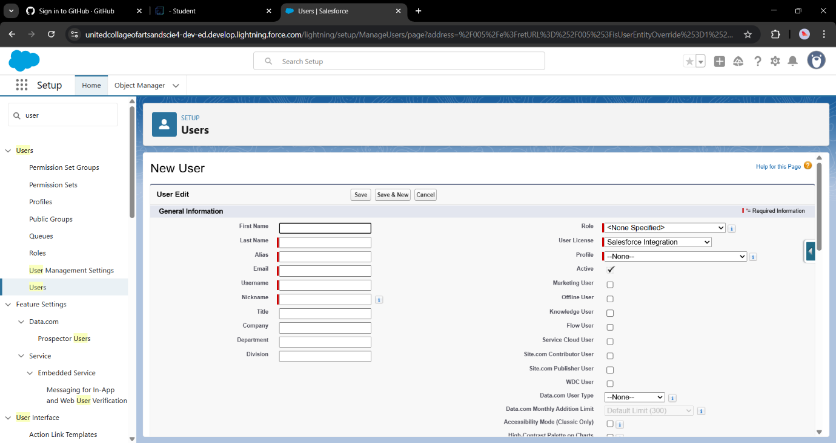

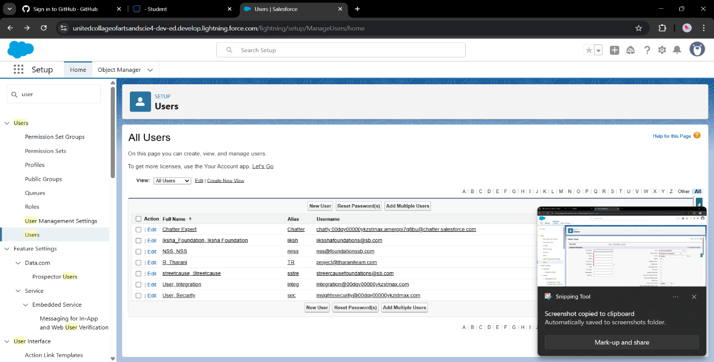

**Public Groups**

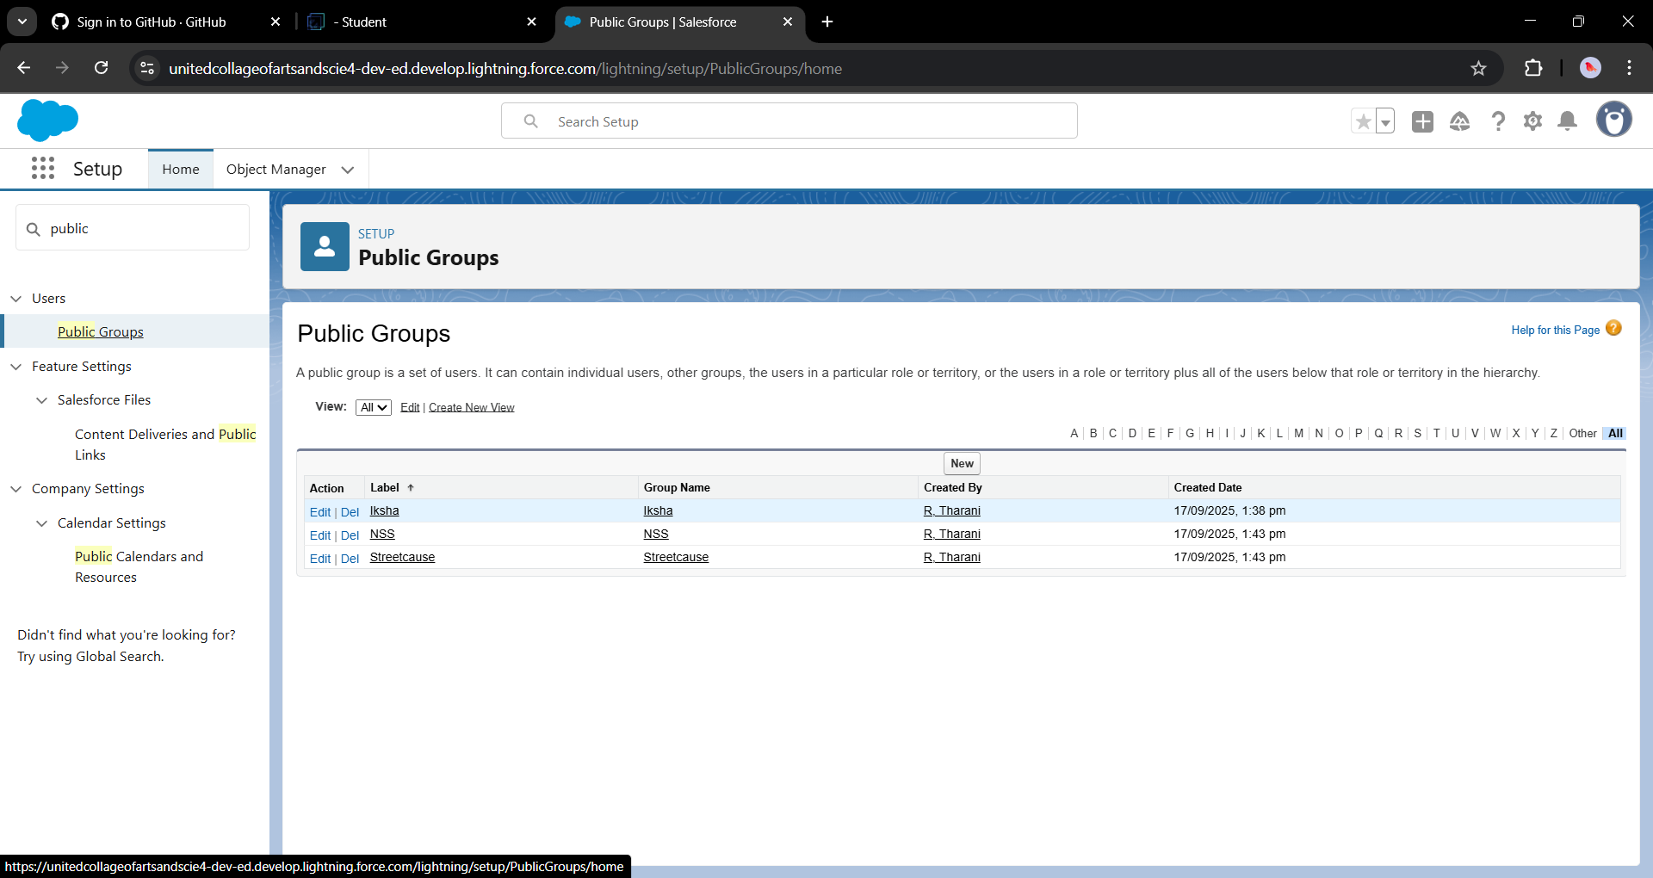

**Report Types**

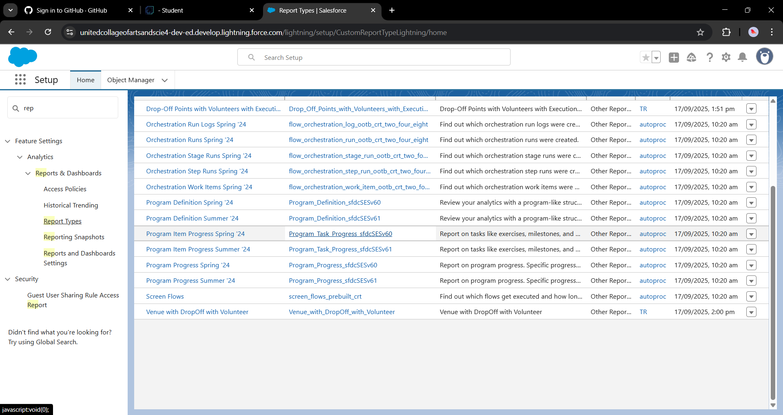

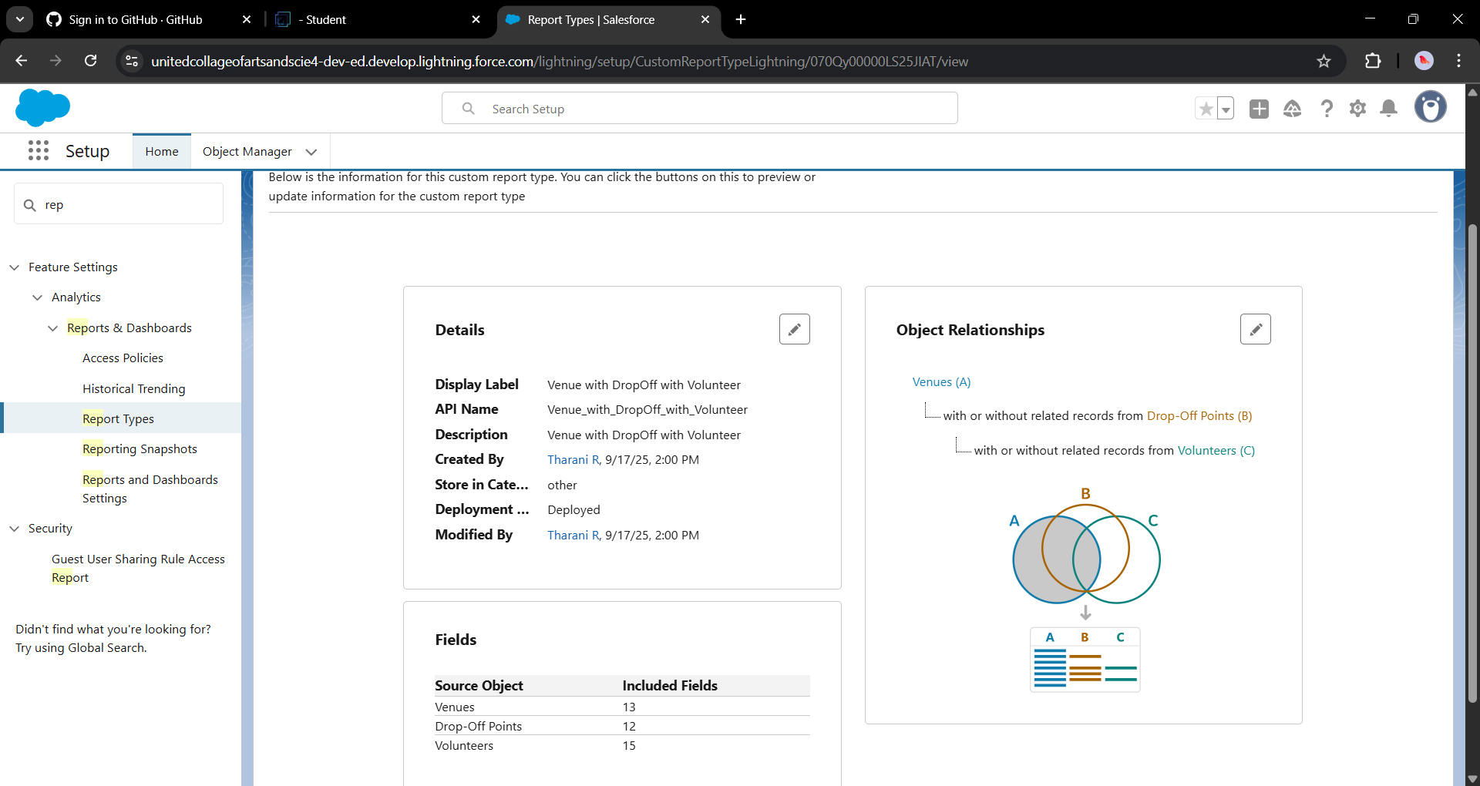

**Reports**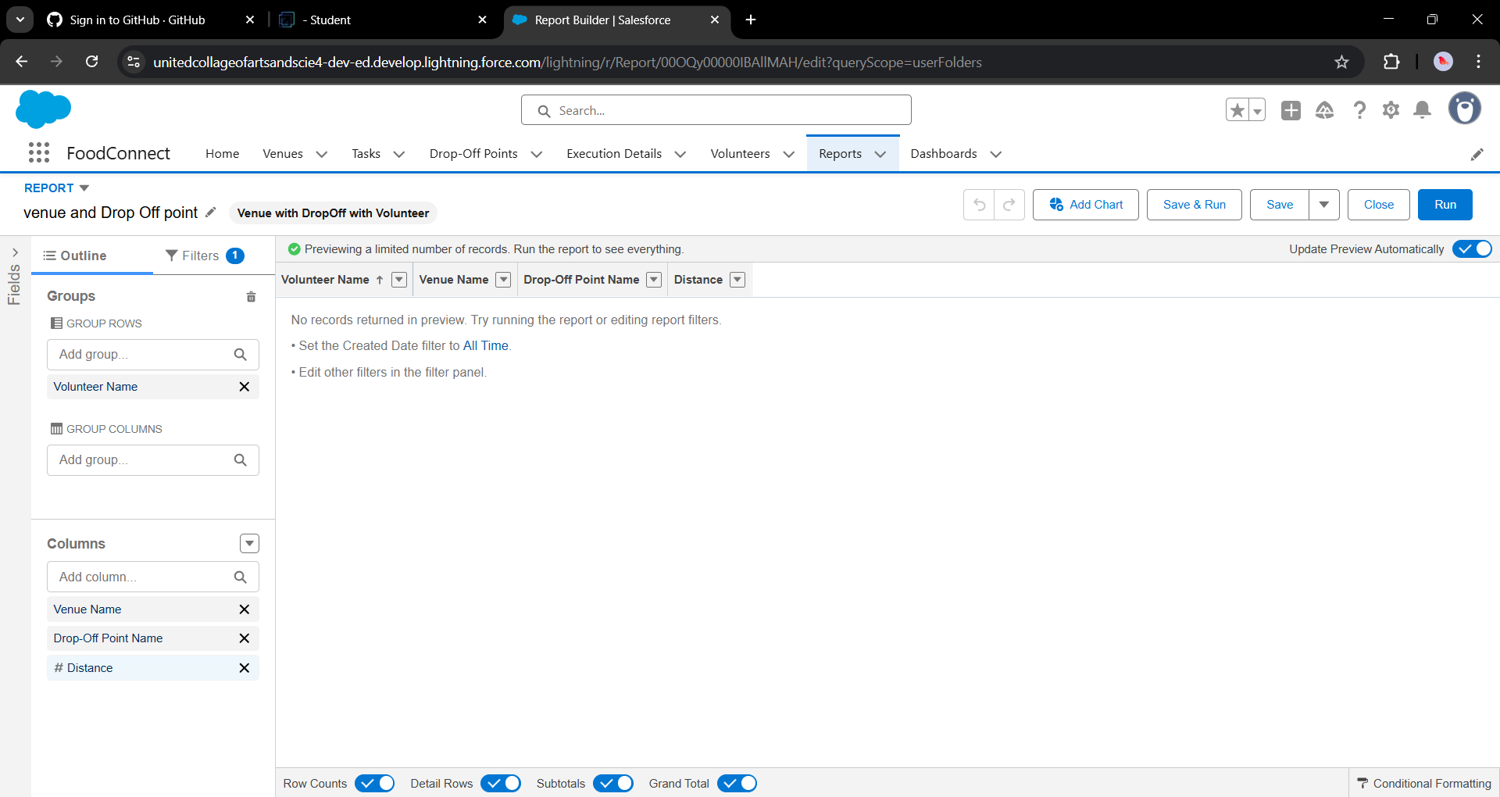

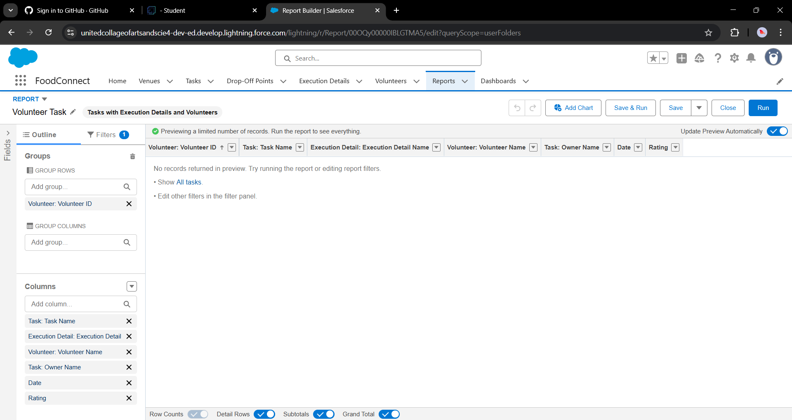

**Dashboards**

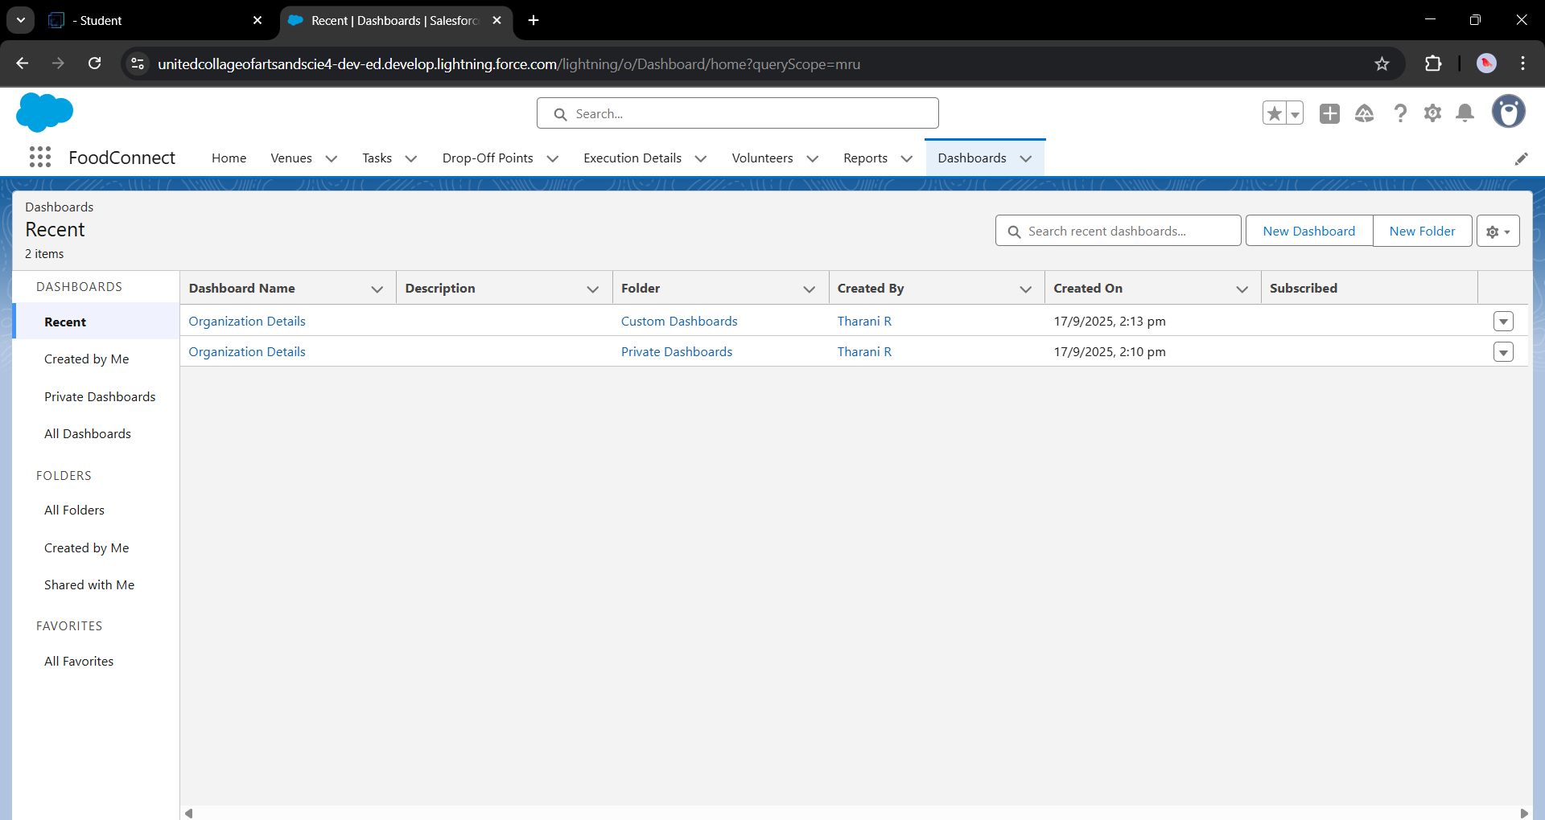

**Home Page**

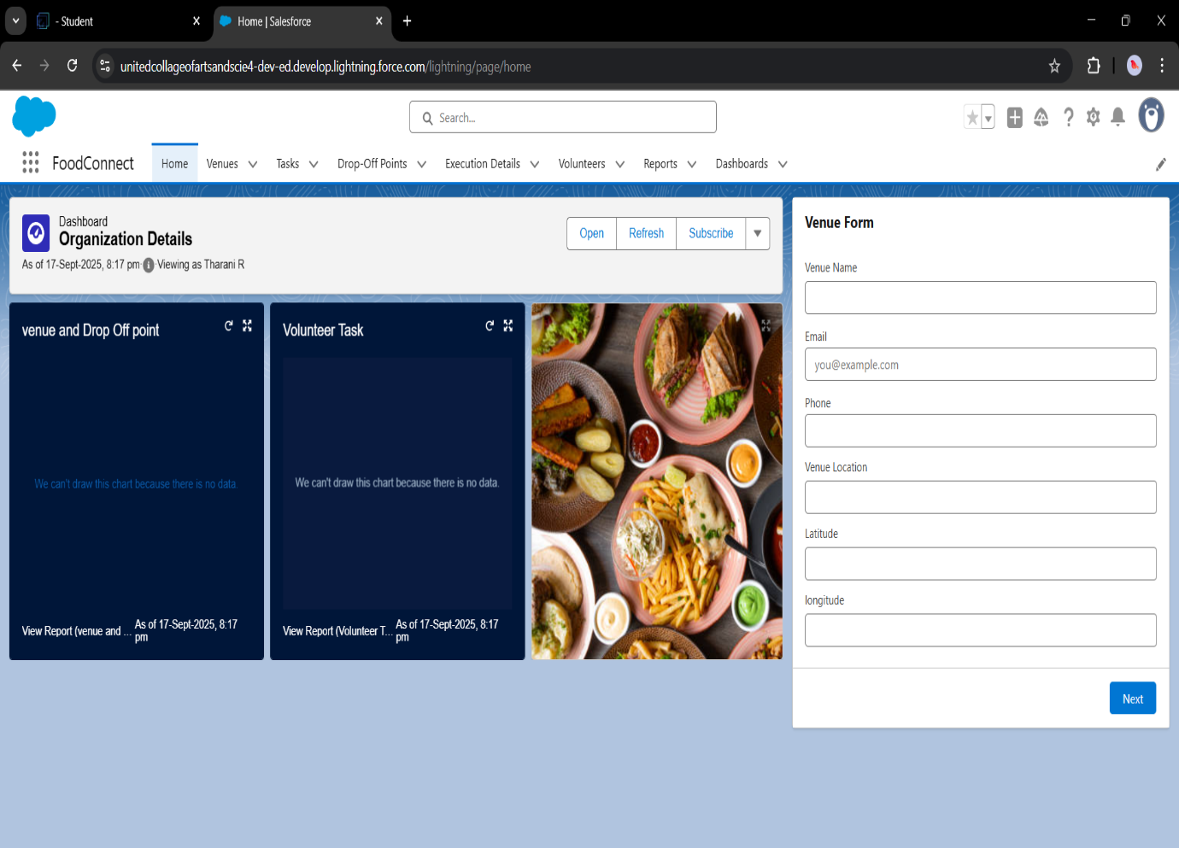

**Conclusion**

By leveraging the Salesforce platform, the project successfully established a streamlined and transparent system for managing surplus food donations. Through efficient coordination with volunteers and timely delivery to beneficiaries, the project effectively addressed food insecurity while maximizing the utilization of available resources.